- Draw a labelled diagram of a typical home WiFi router and a network switch, clearly marking at least 3 different ports (such as WAN, LAN, Console) and the location of status LEDs.
Ans :-
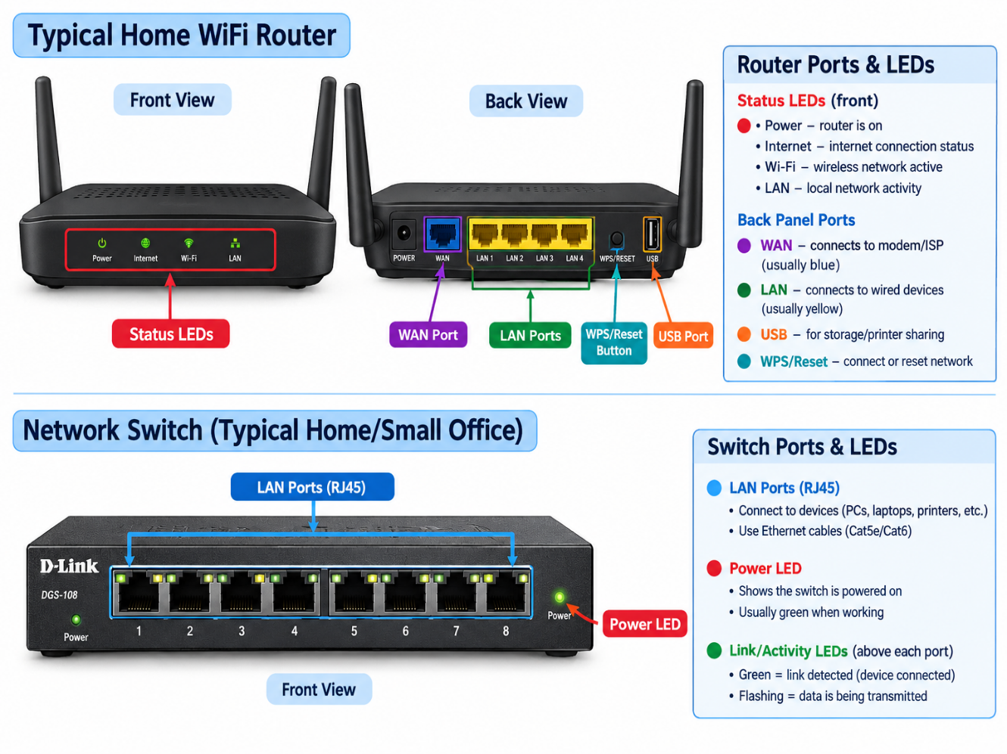

- List 3 key differences between routers and switches in terms of their main functions and how they handle network traffic.<br><br><em><strong>Hint:</strong> Think about how each device deals with IP addresses, MAC addresses, and the types of networks they connect.</em>
Ans :-
Feature | Router | Switch
Main function | Connects different networks, such as a home network and the internet. | Connects devices within the same local network (LAN).
Addresses used | Uses IP addresses to decide where to send packets. | Usually uses MAC addresses to forward Ethernet frames.
Traffic handling | Routes data between networks and can provide NAT and firewall features. | Sends data to the appropriate device port using its MAC address table.

- Take a real or virtual image of a router and a switch (from your home, lab, or Google Images), and identify the following on each: Power port, at least 2 Ethernet ports, and any LED indicators. Annotate the image or describe their position and purpose.
Ans :-
A. Router
- Power port: Usually at the rear; connects the power adapter.
- Ethernet ports: WAN and LAN ports are usually grouped together at the rear.
- LED indicators: Usually on the front or top; show power, internet, Wi-Fi and LAN activity.
B. Network switch
- Power port: Usually at the rear or side; connects the power supply.
- Ethernet ports: Several ports on the front or rear; connect computers and other network devices.
- LED indicators: Usually beside or above the Ethernet ports; show link status, activity and sometimes connection speed.

- Imagine you are setting up a small gaming café network for IPL streaming and multiplayer matches. Write a short scenario explaining which device (router or switch) you would connect first to the ISP line, and how you would connect 8 gaming PCs to the network. Justify your choices.
Ans :-
- First, I connect the ISP line to the modem or ONT supplied by the internet provider.
- I connect the modem or ONT to the router's WAN port.
- I connect a router's LAN port to a Gigabit network switch using an Ethernet cable.
- I connect all eight gaming PCs to the switch using Ethernet cables.
- I configure the router for internet access, DHCP and appropriate security settings.

